|  |  |
| --- | --- |
|  | **AMERICAN INTERNATIONAL UNIVERSITY-BANGLADESH (AIUB)**  Faculty of Engineering  Department of Electrical and Electronic Engineering |

##### ELECTRONIC DEVICES LAB



**\*Rename your pdf file name as: SERIAL_NAME_ID_GR NO_ASSESSMENT NAME & NO.**

**Example: 09_AHMED RAHIM_22-12345-3_GR 03_LAB 01**

**\*Report should be handwritten and PDF in format.**

**\*Topics to be covered: Title >> Objectives >> Theory & Methodology >> Apparatus >> Results & Simulations >> Discussion & Conclusion >> Reference.**

**\*Submit the report before the next lab class in the provided link (check portal notice).**

|  |  |
| --- | --- |
| **SECTION: M** | **SEMESTER: SPRING 23-24** |
| **GROUP NUMBER: 5** | **DATE OF SUBMISSION: 24/04/24** |

**\*Follow the upload rules during submission.**

|  |  |
| --- | --- |
| **SUBMITTED BY** | |
| **NAME: CHINMOY GUHA** | **ID: 22-48056-2** |
| **CLASS SERIAL NUMBER: 14** | **CONTACT: 01706466663** |

|  |
| --- |
| **LAB NO: OEL**  **TITLE: LASER SECURITY SYSTEM** |

|  |  |  |  |
| --- | --- | --- | --- |
| **Class SL** | **Group Member’s Name** | **ID** | **Contact Number** |
| 11 | FERDOUS, AMINA | 22-47822-2 | 01641586846 |
| 12 | UDDIN, MOHAMMAD ANSAR | 22-47975-2 | 01797180123 |
| 13 | TAIEB, ABDULLAH AL | 22-48028-2 | 01642511014 |
| 14 | GUHA, CHINMOY | 22-48056-2 | 01706466663 |
| 15 | CHAKRABORTY, SUVRA | 22-48067-2 | 01996088480 |
|  |  |  |  |
|  |  |  |  |
|  |  |  |  |
|  |  |  |  |
|  |  |  |  |

**SUBMITTED TO:**

**SUJAN HOWLADER (ESSAN), ASSISTANT PROFESSOR**

**DEPARTMENT OF EEE, FACULTY OF ENGINEERING**

**Title of the Experiment:**

**Laser-Based Security System**

* **Objectives**
* To understand the principles of laser light and sensor interaction.
* To design and construct a simple laser-based security system.
* To demonstrate the functionality of a laser security system in detecting intrusions.

**Theory and Methodology**

The core theory behind a laser security system involves the utilization of a laser beam and a light-sensitive sensor to detect disruptions in the beam's path, indicative of potential intrusions. In our experiment, we employ a straightforward optical system consisting of a laser diode and a photodiode. The laser diode emits a focused beam of light that travels across a designated area until it reaches the photodiode, which is positioned to detect the uninterrupted beam.

The methodology encompasses setting up these components on a breadboard, a reusable base for prototyping electronics. This setup facilitates easy adjustments and troubleshooting without soldering. When the laser's light beam is broken, for instance, by an object passing through it, the photodiode detects a drop in light intensity. This change is converted into an electrical signal that triggers an alarm, demonstrated by a buzzer or LED in our system, thereby signaling an intrusion. This experiment not only illustrates the application of optical sensors in security systems but also highlights the principles of electronic circuit configuration and testing.

**Apparatus**

* Breadboard
* BC557 Transistor
* 100k ohm resistor and 330 ohm resistor
* LDR
* Buzzer and LED as an output indicator
* Connecting wires
* Power supply (9V battery)
* Battery connector.

**Experimental Procedure:**

• The BC557 transistor was placed on the breadboard, ensuring that pins were not shorted.

• One end of the LDR was attached to the emitter of the BC557 transistor.

• The other end of the LDR was connected to the negative (ground) rail of the breadboard.

• One end of the 100k ohm resistor was connected to the base of the BC557 transistor.

• The other end of the 100k ohm resistor was attached to the positive rail of the breadboard.

• The cathode (shorter leg) of the LED was connected to the collector of the BC557 transistor.

• The anode (longer leg) of the LED was attached to one end of the 330 ohm resistor.

• The other end of the 330 ohm resistor was connected to the positive rail of the breadboard.

• One terminal of the buzzer was connected to the collector of the BC557 transistor.

• The other terminal of the buzzer was attached to the positive rail of the breadboard using another 330 ohm resistor (to limit the current).

• The positive terminal of the battery connector was attached to the positive rail of the breadboard.

• The negative terminal of the battery connector was connected to the ground rail.

• All connections were double-checked for correctness, ensuring there were no loose connections or shorts.

• The circuit was powered by connecting the 9V battery.

• The LDR was covered and uncovered to simulate changes in light. Observations were made regarding whether the LED lit up and the buzzer sounded when the LDR was covered (indicating reduced light).

• If the LED or buzzer did not operate as expected, the polarity of connections was verified, and it was ensured that the LDR was significantly covered to activate the transistor.

**CIRCUIT:**

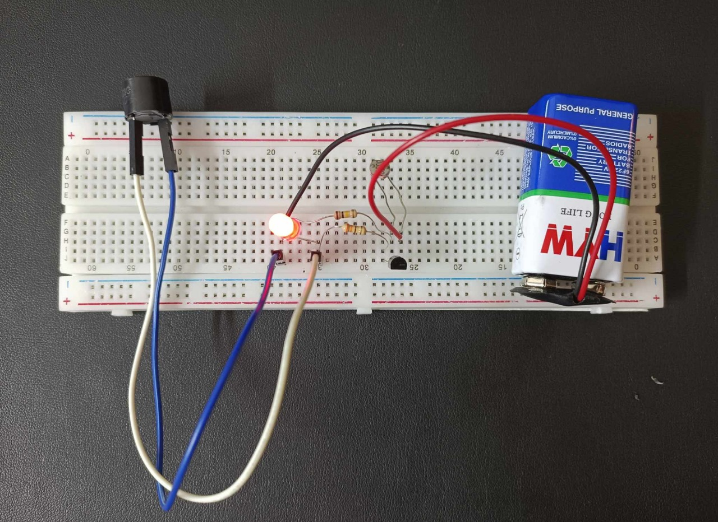

**SIMULATION:  
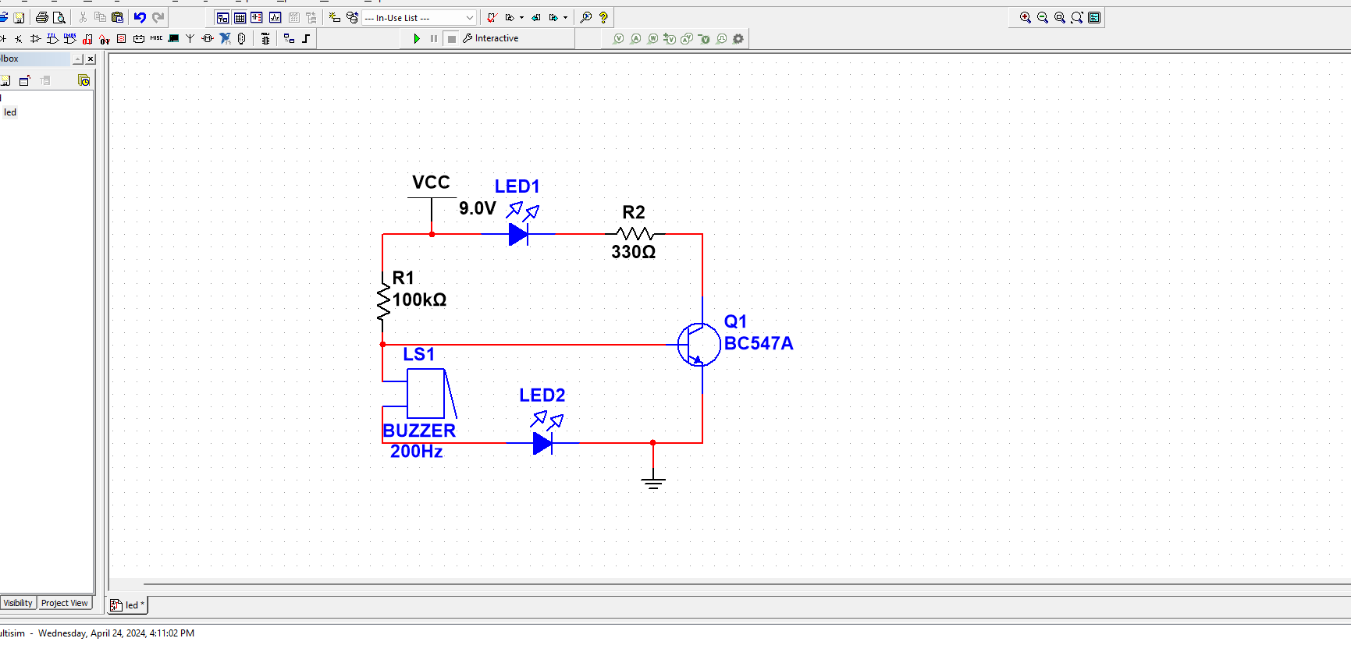**

**(due to the absence of LDR in the multisim software, an LED was used to simulate it)**

**EXPERIMENTAL DATA (RESULT):**This result was observed upon construction of the laser security system.

|  |  |
| --- | --- |
| *Laser Interference:* | *Buzzer Status:* |
| Laser ON | BUZZER OFF |
| Laser OFF | BUZZER ON |

**Discussion and Conclusion**

In this experiment, the construction of a laser-based security system using a PNP transistor (BC557), an LDR, LED, buzzer, and a power source was successfully demonstrated. The system was designed to activate an alarm (buzzer) and a visual indicator (LED) when the LDR detected a significant reduction in light, simulating an intruder passing through a laser beam.One of the key challenges faced during the experiment was ensuring the sensitivity of the LDR was appropriately calibrated for the light conditions. Initially, the LDR did not trigger the transistor reliably, causing intermittent activation of the LED and buzzer. Adjustments were made by experimenting with different resistor values and repositioning the LDR to optimize its exposure to the laser light.

The experiment conclusively demonstrated the practical application of basic electronic components in creating functional security systems. It also highlighted the importance of precise component placement and calibration in electronics, providing valuable hands-on experience in troubleshooting and iterative testing in circuit design. This experience underlines the critical nature of component sensitivity and environmental factors in the functionality of light-based security systems.

**REFERENCES:**

https://www.instructables.com/How-to-Make-a-Laser-Security-Alarm-System-at-Home-/

https://circuitdigest.com/electronic-circuits/laser-security-alarm-circuit-diagram

https://www.slideshare.net/slideshow/laser-security-system-72827462/72827462

https://www.electronicshub.org/laser-security-system/

https://papers.ssrn.com/sol3/Delivery.cfm/SSRN_ID3919037_code4821933.pdf?abstractid=3919037&mirid=1